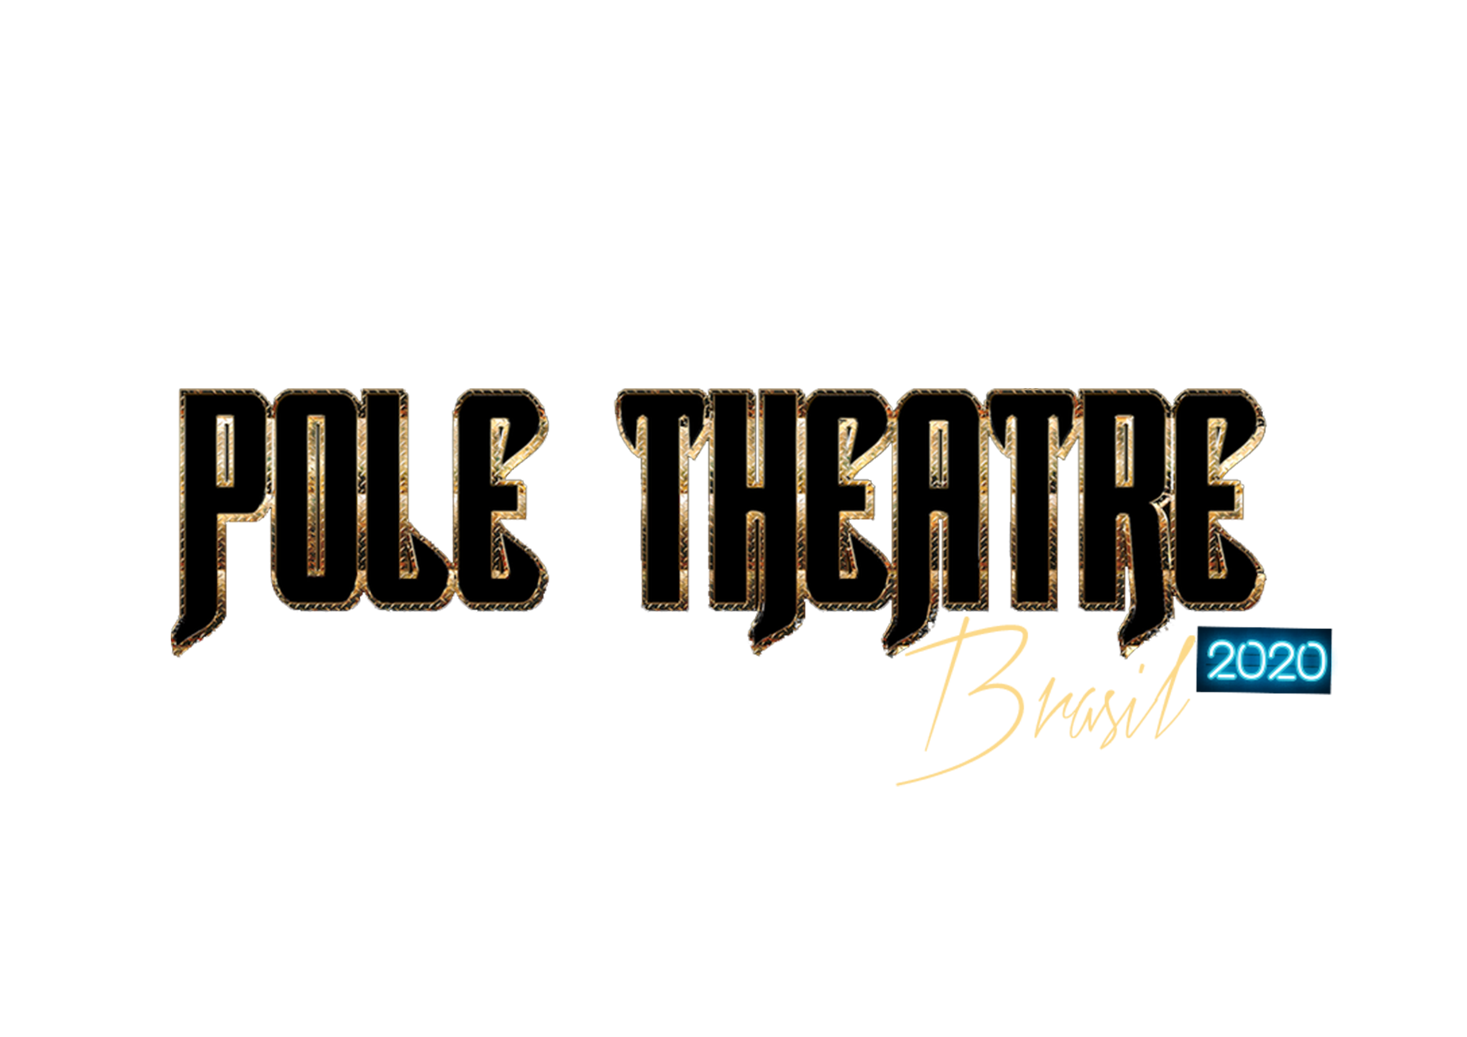

ENTRY FORM POLE THEATRE BRAZIL 2020
NAME:___________________________________________________________
BIRTH DATE:____________________
PASSPORT NUMBER:____________________________
ADRESS:________________________________________________________COUNTRY _____________________________
PHONE NUMBER: ________________ EMAIL:_________________________________
PAYMENT TICKET: ___________________________
DIVISION:
( ) AMATEUR
( ) SEMIPRO
( ) PROFESSIONAL
CATEGORY
( ) DRAMA
( )ART
( )COMEDY
( )CLASSIQUE
SECOND OPTION CATEGORY (NOT MANDATORY)
( ) DRAMA
( )ART
( )COMEDY
( )CLASSIQUE
STATEMENT OF RESPONSIBILITY
I, ______________________________________________________________, am responsible for the veracity of the information presented above. I DECLARE that I am able to perform physical activities and that the organizing institution of the event is not responsible if I suffer sudden illness or suffer some type of accident during the event.
By this instrument, I DECLARE that I read the POLE THEATER BRAZIL Regulation and that I agree with all the terms established there.

Local:

Date:

Signature:
SCRIPT:

ENTRANCE FEE: R$ 180,00 INDIVIDUAL
R$ 230,00 DOUBLES
LINK TO PAYMENT
INDIVIDUAL (R$180,00):
https://link.pagar.me/lr19CCsQdr
DOUBLES (R$230,00):
https://link.pagar.me/lSyWXJ2QuB
BANK TRANSFERS

Urbium Comércio e Eventos Ltda.
CNPJ: 33.337.513/0001-41
Bank: 077
Ag: 0001
Account : 31638180

